Lab Experiment: 4

Title: Application of Classification Algorithm (J48) for Decision Tree Construction

Course title: Data Mining Problem Description

Course code: CSE-452
4th Year 1st Semester Examination 2025

Date of Submission: 26/02/2026

Submitted to-

Md. Humayun Kabir
Professor
Department of Computer Science and Engineering
Jahangirnagar University

&

Dr. Md Musfique Anwar
Professor
Department of Computer Science and Engineering
Jahangirnagar University
Savar, Dhaka-1342

Class Roll | Exam Roll | Name
383 | 210903 | Abdullah Nazmus-Sakib
379 | 210899 | Shah Sultan
391 | 210911 | Md Khaled Mahmud
395 | 210915 | Tawhidul Islam

1. Objective
To apply the J48 decision tree classification algorithm on a student performance dataset, construct a pruned decision tree, and evaluate the model using 10-fold cross-validation.

2. Tools & Software
- WEKA (Waikato Environment for Knowledge Analysis)
- Microsoft Excel / Google Sheets
- Dataset in CSV and ARFF format

3. Dataset Description
The dataset contains academic results of students across three academic years and their overall performance class.
Relation Name: Student_Performance
Number of Instances: 52
Number of Attributes: 5
Attribute | Description
FirstYear | GPA of first year
SecondYear | GPA of second year
ThirdYear | GPA of third year
AVG_Till_Now | Average GPA till current year
Performance_Class | Final performance category (target)
Target Classes: Excellent, Good, Average, Poor

4. Methodology / Procedure
- Prepared dataset in Excel sheet.
- Saved the dataset in CSV format.
- Converted CSV file into ARFF format using WEKA.
- Loaded the ARFF file into WEKA Explorer.
- Selected Classify → J48 algorithm.
- Used default parameters (Confidence Factor = 0.25, MinNumObj = 2).
- Applied 10-fold cross-validation.
- Generated and visualized the decision tree.
- Evaluated model performance using accuracy metrics and confusion matrix.

5. J48 Model Information
- Scheme: weka.classifiers.trees.J48
- Confidence Factor (C): 0.25
- Minimum Instances per Leaf (M): 2
- Tree Type: Pruned Tree

Tree Size: 7 nodes
Number of Leaves: 4
Time to Build Model: 0 seconds

6. Generated Decision Tree (Rules)

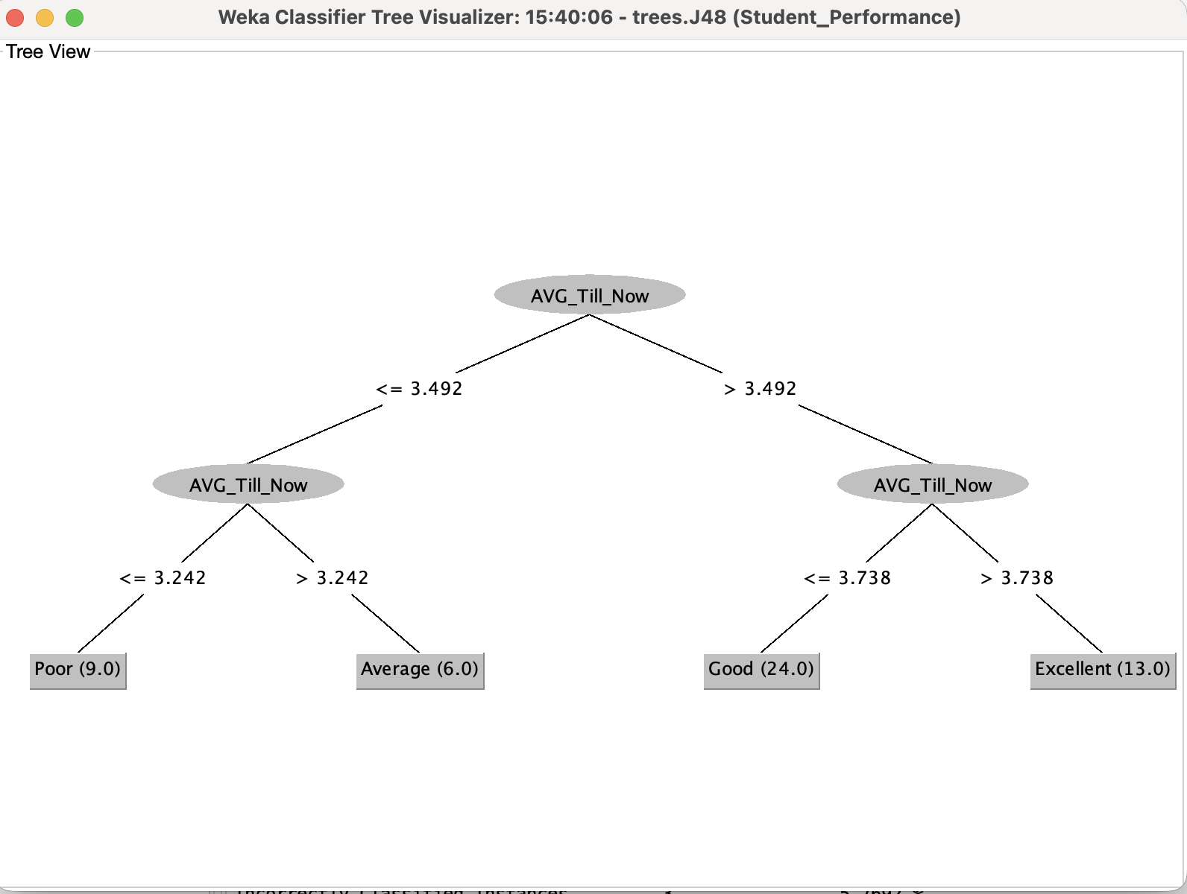

The tree uses only the attribute AVG_Till_Now to classify student performance.
IF AVG_Till_Now ≤ 3.242 → Performance = Poor
IF 3.242 < AVG_Till_Now ≤ 3.492 → Performance = Average
IF 3.492 < AVG_Till_Now ≤ 3.738 → Performance = Good
IF AVG_Till_Now > 3.738 → Performance = Excellent
This shows that overall GPA is the most significant factor in determining performance class.

7. Evaluation Results (10-Fold Cross-Validation)

7.1 Summary Statistics
- Correctly Classified Instances: 49 (94.23%)
- Incorrectly Classified Instances: 3 (5.77%)
- Kappa Statistic: 0.9151 (Very high agreement)
- Mean Absolute Error: 0.0288
- Root Mean Squared Error: 0.1698

Interpretation: The model demonstrates excellent predictive performance.

7.2 Accuracy by Class
Class | Precision | Recall | F-Measure
Excellent | 0.929 | 1.000 | 0.963
Good | 0.958 | 0.958 | 0.958
Average | 0.833 | 0.833 | 0.833
Poor | 1.000 | 0.889 | 0.941

This table shows how well the model predicts each performance category individually.
- Precision → How many predicted cases of a class were actually correct
- Recall → How many actual cases of a class were correctly identified
- F-Measure → Overall balance between Precision and Recall

Interpretation:
- Excellent:
Model identified all Excellent students correctly (Recall = 1.000). Very reliable predictions.
- Good:
High accuracy (0.958). Only very few mistakes.
- Average:
Lowest performance (0.833). Some Average students were misclassified.
- Poor:
Perfect Precision (1.000) → Whenever the model predicts Poor, it is always correct.
Recall is slightly lower (0.889) → One Poor student was predicted as another class.

Overall: The classifier performs very well for all classes, especially Excellent and Good.

7.3 Confusion Matrix
Actual \ Predicted | Excellent | Good | Average | Poor
Excellent | 13 | 0 | 0 | 0
Good | 1 | 23 | 0 | 0
Average | 0 | 1 | 5 | 0
Poor | 0 | 0 | 1 | 8

This table shows the exact number of correct and incorrect predictions made by the model.
- Rows = Actual class
- Columns = Predicted class
- Diagonal values = Correct predictions
- Off-diagonal values = Errors

Interpretation:
- Excellent:
All 13 students correctly classified → Perfect performance.
- Good:
23 correct, 1 misclassified as Excellent.
- Average:
5 correct, 1 misclassified as Good.
- Poor:
8 correct, 1 misclassified as Average.

Most values are on the diagonal → The model is highly accurate (94.23%).

8. Discussion
- The J48 algorithm selected only one attribute (AVG_Till_Now) for classification.
- This indicates that cumulative GPA strongly determines final performance.
- The model achieved high accuracy (94.23%), showing that the dataset is well structured and separable.
- Minor misclassifications occurred between adjacent performance categories (e.g., Good vs Excellent).

9. Conclusion

The experiment successfully applied the J48 decision tree algorithm to classify student performance. The resulting model is simple, interpretable, and highly accurate. The study demonstrates that overall GPA is the dominant factor in predicting academic performance categories.

10. Precautions
- Ensure dataset has no missing or inconsistent values.
- Normalize or verify GPA scale consistency.
- Choose appropriate class labels.
- Use cross-validation to avoid overfitting.

11. Applications
- Academic performance prediction systems
- Student monitoring and advising tools
- Early identification of at-risk students
- Educational data mining research

